**Project Stage - I Report on**

## RAINFALL PRO – MINI METEROLOGY FOR QUICK PREDICTIONS

Submitted in Partial fulfillment of requirements for the award of the degree of

**BACHELOR OF TECHNOLOGY**

**In**

**COMPUTER SCIENCE AND ENGINEERING**

**By**

**MARNENI PRASHANTH BABU 20BD1A0552**

**SILIVERU AKASH DURGA 20BD1A055J**

**SRIVATSA ROHIT KALAVAPUDI 20BD1A055L**

**YELTY VISHNU VARDHAN REDDY 20BD1A055U**

**Under the guidance of**

***Mr.Ch Kumaraswamy***

***Assistant Professor, Department of CSE***



**DEPARTMENT OF COMPUTER SCIENCE AND ENGINEERING**

## KESHAV MEMORIAL INSTITUTE OF TECHNOLOGY

**(AN AUTONOMOUS INSTITUTION)**

**Accredited by NBA & NAAC, Approved by AICTE, Affiliated to JNTUH.**

**Narayanaguda, Hyderabad, Telangana-29**

**2023-24**

## KESHAV MEMORIAL INSTITUTE OF TECHNOLOGY

**(AN AUTONOMOUS INSTITUTION)**

**Accredited by NBA & NAAC, Approved by AICTE, Affiliated to JNTUH.**

**Narayanaguda, Hyderabad, Telangana-29**



## DEPARTMENT OF COMPUTER SCIENCE AND ENGINEERING CERTIFICATE

This is to certify that this is a bonafide record of the report titled **“RAINFALL PRO – MINI METEROLOGY FOR QUICK PREDICTIONS”** which is being presented as the project stage-I report by

1. **MARNENI PRASHANTH BABU 20BD1A0552**
2. **SILIVERU AKASH DURGA 20BD1A055J**
3. **SRIVATSA ROHIT KALAVAPUDI 20BD1A055L**
4. **YELTY VISHNU VARDHAN REDDY 20BD1A055U**

In partial fulfillment for the award of the degree of Bachelor of Technology in Computer Science and Engineering affiliated to the Jawaharlal Nehru Technological University Hyderabad, Hyderabad

**Faculty Supervisor Head of Department**

**(Mr.Ch Kumara Swamy) (Mr. P. Upendar)**

# Vision & Mission of KMIT

## Vision of KMIT

* To be the fountainhead in producing highly skilled, globally competent engineers.
* Producing quality graduates trained in the latest software technologies and related tools and striving to make India a world leader in software products and services.

## Mission of KMIT

* To provide a learning environment that inculcates problem solving skills, professional, ethical responsibilities, lifelong learning through multi modal platforms and prepares students to become successful professionals.
* To establish an industry institute Interaction to make students ready for the industry.
* To provide exposure to students on the latest hardware and software tools.
* To promote research-based projects/activities in the emerging areas of technology convergence.
* To encourage and enable students to not merely seek jobs from the industry but also to create new enterprises.
* To induce a spirit of nationalism which will enable the student to develop, understand India's challenges and to encourage them to develop effective solutions.
* To support the faculty to accelerate their learning curve to deliver excellent service to students.

# Vision & Mission of CSE

## Vision of the CSE

To be among the region's premier teaching and research Computer Science and Engineering departments producing globally competent and socially responsible graduates in the most conducive academic environment.

## Mission of the CSE

* To provide faculty with state of the art facilities for continuous professional development and research, both in foundational aspects and of relevance to emerging computing trends.
* To impart skills that transform students to develop technical solutions for societal needs and inculcate entrepreneurial talents.
* To inculcate an ability in students to pursue the advancement of knowledge in various specializations of Computer Science and Engineering and make them industry-ready.
* To engage in collaborative research with academia and industry and generate adequate resources for research activities for seamless transfer of knowledge resulting in sponsored projects and consultancy.
* To cultivate responsibility through sharing of knowledge and innovative computing solutions that benefit the society-at-large.
* To collaborate with academia, industry and community to set high standards in academic excellence and in fulfilling societal responsibilities

# PROGRAM OUTCOMES (POs)

**PO1. Engineering Knowledge:** Apply the knowledge of mathematics, science, engineering fundamentals, and an engineering specialization to the solution ofcomplex engineering problems.

**PO2. Problem Analysis:** Identify formulate, review research literature, and analyze complex engineering problems reaching substantiated conclusions using first principles of mathematics, natural sciences, and engineering sciences

**PO3. Design/Development of solutions:** Design solutions for complex engineering problems and design system components or processes that meet the specified needs with appropriate consideration for the public health and safety, and the cultural, societal, and environmental considerations.

**PO4. Conduct Investigations of Complex problems:** Use research-based knowledge and research methods including design of experiments, analysis and interpretationof data, and synthesis of the information to provide valid conclusions.

**PO5. Modern Tool Usage:** Create select, and, apply appropriate techniques, resources, and modern engineering and IT tools including prediction and modeling to complex engineering activities with an understanding of the limitations.

**PO6. The Engineer and Society:** Apply reasoning informed by contextual knowledge to societal, health, safety. Legal und cultural issues and the consequent responsibilities relevant to professional engineering practice.

**PO7. Environment and Sustainability:** Understand the impact of the professional engineering solutions in societal and environmental contexts and demonstrate the knowledge of, and need for sustainable development.

**PO8. Ethics:** Apply ethical principles and commit to professional ethics and responsibilities and norms of the engineering practice.

**PO9. Individual and Team Work:** Function effectively as an individual, and as a member or leader in diverse teams and in multidisciplinary settings.

**PO10. Communication:** Communicate effectively on complex engineering activities with the engineering community and with society at large, such as, being able to comprehend and write effective reports and design documentation, make effective presentations, and give and receive clear instructions.

**PO11. Project Management and Finance:** Demonstrate knowledge and understanding of the engineering and management principles and apply these to one's own work, as a member and leader in a team, to manage projects and in multidisciplinary environments.

**PO12. Life-Long Learning:** Recognize the need for, and have the preparation and ability to engage in independent and life-long learning in the broadest context of technological change.

# PROGRAM SPECIFIC OUTCOMES (PSOs)

**PSO1:** An ability to analyze the common business functions to design and develop appropriate Information Technology solutions for social upliftments.

**PSO2:** Shall have expertise on the evolving technologies like Python, Machine Learning, Deep learning, IOT, Data Science, Full stack development, Social Networks, Cyber Security, Mobile Apps, CRM, ERP, Big Data, etc.

# PROGRAM EDUCATIONAL OBJECTIVES (PEOs)

**PEO1:** Graduates will have successful careers in computer related engineering fields or will be able to successfully pursue advanced higher education degrees.

**PEO2:** Graduates will try and provide solutions to challenging problems in their profession by applying computer engineering principles.

**PEO3:** Graduates will engage in life-long learning and professional development by rapidly adapting to the changing work environment.

**PEO4:** Graduates will communicate effectively, work collaboratively and exhibit high levels of professionalism and ethical responsibility.

# DECLARATION

We hereby declare that the results embodied in the dissertation entitled **“**RAINFALL PRO – MINI METEROLOGY FOR QUICK PREDICTIONS” has been carried out by us together during the academic year 2023-24 as a partial fulfillment of the award of the B.Tech degree in Computer Science and Engineering from JNTUH. We have not submitted this report to any other university or organization for the award of any other degree.

## Student Name Rollno.

**MARNENI PRASHANTH BABU 20BD1A0552**

## SILIVERU AKASH DURGA 20BD1A055J

**SRIVATSA ROHIT KALAVAPUDI 20BD1A055L**

**YELTY VISHNU VARDHAN REDDY 20BD1A055U**

**KESHAV MEMORIAL INSTITUTE OF TECHNOLOGY   
(AN AUTONOMOUS INSTITUTION)  
Accredited by NBA & NAAC, Approved by AICTE, Affiliated to JNTUH.**



### Narayanaguda,Hyderabad,Telangana-29

**TEAM NO:**

**IOMP TITLE:**

# PROJECTOUTCOMES

**P1: Efficiently analyze rainfall-related data to accurately predict rainfall patterns and trends.**

**P2: Provide users with a seamless and intuitive web interface for viewing and interacting with rainfall prediction data and visualizations, and integrate the machine learning model with the web interface.**

**P3: Ensure real-time responsiveness to user input, allowing for instant updates to rainfall prediction results and visualizations.**

**P4: Establish a secure remote access mechanism for users to access and view rainfall prediction data and visualizations from anywhere.**

**MAPPING PROJECTOUTCOMESWITH PROGRAMOUTCOMES**

|  |  |  |  |  |  |  |  |  |  |  |  |  |
| --- | --- | --- | --- | --- | --- | --- | --- | --- | --- | --- | --- | --- |
| **PO** | **PO1** | **PO2** | **PO3** | **PO4** | **PO5** | **PO6** | **PO7** | **PO8** | **PO9** | **PO10** | **PO11** | **PO12** |
| **P1** | H | H | H | H | M | M | H | M | H | H | H | H |
| **P2** | H | H | H | M | H | H | H | H | H | H | H | H |
| **P3** | H | H | H | H | H | H | H | H | M | H | H | H |
| **P4** | M | H | H | H | H | H | M | H | H | H | H | H |

L– LOW M –MEDIUM H– HIGH

**PROJECT OUTCOMES MAPPING WITH PROGRAM SPECIFIC OUTCOMES**

|  |  |  |
| --- | --- | --- |
| **PSO** | **PSO1** | **PSO2** |
| **P1** | 3 | 3 |
| **P2** | 3 | 2 |
| **P3** | 3 | 2 |
| **P4** | 2 | 2 |

**PROJECT OUTCOMES MAPPING WITH PROGRAM EDUCATIONAL OBJECTIVES**

|  |  |  |  |  |
| --- | --- | --- | --- | --- |
| **PEO** | **PEO1** | **PEO2** | **PEO3** | **PEO4** |
| **P1** | 3 | 3 | 2 | 2 |
| **P2** | 3 | 3 | 2 | 2 |
| **P3** | 3 | 3 | 3 | 2 |
| **P4** | 2 | 3 | 3 | 3 |

**FACULTY SUPERVISOR SIGN:**

# ACKNOWLEDGEMENT

We take this opportunity to thank all the people who have rendered their full support to our project work. We render our thanks to **Dr. B L Malleswari**, Principal who encouraged us to do the Project.

We are grateful to **Mr. Neil Gogte**, Founder & Director, **Mr. S. Nitin,** Director for facilitating all the amenities required for carrying out this project.

We express our sincere gratitude to **Ms. Deepa Ganu**, Director Academic for providing an excellent environment in the college.

We are also thankful to **Mr. P Upendar**, Head of the Department for providing us with time to make this project a success within the given schedule.

We are also thankful to our Faculty Supervisor **Mr. Ch Kumaraswamy**, for her/his valuable guidance and encouragement given to us throughout the project work.

We would like to thank the entire CSE Department faculty, who helped us directly andindirectly in the completion of the project.

We sincerely thank our friends and family for their constant motivation during the project work.

## Student Name Rollno.

**MARNENI PRASHANTH BABU 20BD1A0552**

## SILIVERU AKASH DURGA 20BD1A055J

**SRIVATSA ROHIT KALAVAPUDI 20BD1A055L**

**YELTY VISHNU VARDHAN REDDY 20BD1A055U**



**KESHAV MEMORIAL INSTITUTE OF TECHNOLOGY**

II

**(An Autonomous Institute)**

**(Accredited by NBA & NAAC, Approved By A.I.C.T.E., Reg by Govt of Telangana State & Affiliated to JNTU, Hyderabad)**

|  |  |  |
| --- | --- | --- |
|  | **INDEX** |  |
| **Table of Contents** |  | **Page No.** |

### S.No. Topic

Abstract I

List of Figures II

1. Introduction 1
   1. Background and Motivation… 3
   2. Problem Statement… 5
   3. Objectives… 7
   4. Scope and Limitations… 11
   5. Organization of the Document……………………………………………..17

2. System Requirement Specifications ……………………………………………. 19

2.1 What is SRS?………...................................................................................... 19

* 1. Role of SRS … 19
  2. Requirements Specification Document 20
  3. Functional Requirement Specification……………………………………...20
  4. Performance Requirements…………………………………………………21
  5. Non Functional Requirements………………………………………….…...22
  6. Hardware Requirements………………………………………………..…...23
  7. Software Requirements……………………………………………………..24

3. Literature Survey ...………………………………………………………………. 26

* 1. Relevant Research Papers and Projects……….............................................. 26

3.2Theoretical Framework … 28

1. System Design 30
2. Implementation… 34
   1. Description of Project Execution 34
   2. Code Structure and Architecture 36
   3. Technical Challenges and Solutions 39
3. Testing………………………………………………………………………………….36
4. Screenshots … 46

7.1Approach Description 50

7.2Presentation Of Results…………………………………………………………52

1. Conclusion And Future Work 54

8.1Summary of Achievements. 54

8.2Contribution to the Field 56

8.3Future work and recommendations 58

1. References… 60

**KESHAV MEMORIAL INSTITUTE OF TECHNOLOGY**

iiI

**(An Autonomous Institute)**

**(Accredited by NBA & NAAC, Approved By A.I.C.T.E., Reg by Govt of Telangana State & Affiliated to JNTU, Hyderabad)**

## Abstract

Rainfall prediction is a critical facet of weather forecasting, influencing various sectors such as agriculture, disaster management, and infrastructure planning. Traditional methods often fall short in accurately capturing the complexities of meteorological variables that determine rainfall. This project addresses this challenge by leveraging advanced data collection, mathematical modeling, and machine learning techniques to create a robust predictive model.

The project's primary objective is twofold: to develop a machine learning model capable of accurately forecasting rainfall based on the analysis of historical weather data and current atmospheric conditions, and to seamlessly integrate this model into a user-friendly application. This application aims to provide stakeholders with real-time and precise rainfall predictions, empowering them to make informed decisions in a timely manner.

The anticipated outcomes include the development of an advanced predictive model that surpasses the limitations of traditional methods, offering increased accuracy in rainfall forecasts. The integration of this model into an application is expected to revolutionize decision-making processes across sectors, facilitating optimized resource allocation, improved agricultural practices, and enhanced community safety.

**KESHAV MEMORIAL INSTITUTE OF TECHNOLOGY**

II

**(An Autonomous Institute)**

**(Accredited by NBA & NAAC, Approved By A.I.C.T.E., Reg by Govt of Telangana State & Affiliated to JNTU, Hyderabad)**

***List of Figures***

**Fig. No. Figure Name Page No.**

4.2 Uml Diagram 33

5.2.1 App Directory 37

5.2.2 Project Directory View 38

6.1 Unit Test Life Cycle 42

6.2 Integration Testing 43

6.3 Types of system testing 43

6.4 Performance Testing 44

6.5 Security Testing 44

7.1 Home Page 46

7.2 Login Page 46

7.3 Signup Page 47

7.4 Prediction Page 47

7.5 Output sample 48

7.6 Previous Prediction Page 48

7.7 Django Site Administration Page 49

7.8 List of Users Page 49

7.2.1 Results Page 52

# INTRODUCTION

Rainfall prediction involves estimating whether it will rain or not. This is done by analyzing various meteorological factors such as minimum and maximum temperature, evaporation rate, sunshine duration, humidity levels, atmospheric pressure, diurnal temperature variations, and wind speed. The project employs advanced data collection methods, mathematical modeling, and machine learning techniques to understand the connections between these meteorological variables and the likelihood of rainfall. By studying past weather data and current atmospheric conditions, the project aims to create a model that can accurately predict rain. Despite the intricate nature of the climate system, modern technology aids in unraveling complexities and improving prediction accuracy. The expected outcome is an enhanced predictive model that can assist stakeholders in making informed decisions based on the possibility of rainfall.

Rainfall is a fundamental aspect of our environment, impacting numerous aspects of human life, from agriculture and water resource management to disaster preparedness and infrastructure planning. The ability to predict rainfall accurately holds the key to optimizing these sectors, making them more sustainable, efficient, and responsive to changing weather conditions.

Traditional methods of rainfall prediction have limitations when dealing with the intricate dynamics of weather patterns. Meteorological variables interact in complex ways, making it challenging to determine when and where rainfall will occur. However, the advent of advanced data collection techniques and machine learning offers new avenues for tackling this problem. By analyzing vast amounts of historical weather data and real-time atmospheric conditions, we can build predictive models capable of identifying subtle patterns that were previously beyond our grasp.

The "Rainfall Prediction" project is driven by a deep-seated motivation to address the challenges associated with rainfall prediction. We are inspired by the potential to harness modern technology and scientific advancements to significantly enhance the precision of rainfall forecasts. By doing so, we aim to make a substantial positive impact on various sectors and improve the lives of those who depend on accurate weather information.

The objectives of this project are two-fold. First, we strive to develop a robust machine learning model that excels in rainfall prediction by examining historical meteorological data and current atmospheric parameters. Second, we aim to seamlessly integrate this model into an application that can provide up-to-the-minute rainfall predictions. These objectives, once achieved, have the potential to revolutionize how various stakeholders, including farmers, disaster management agencies, and construction firms, make decisions and allocate resources in response to changing weather conditions.

While we are ambitious in our goals, we acknowledge the scope and limitations of this project. We will work within the bounds of available data and computational resources, recognizing that there may be rare or extreme weather events that challenge the accuracy of our predictions. Nevertheless, we are confident that our efforts will yield a valuable tool for decision-makers across sectors, ultimately contributing to more informed, sustainable, and efficient practices.

## Background and Motivation

In this section, you should provide a detailed background on the importance of rainfall prediction. Discuss the various sectors and activities that rely on accurate rainfall forecasts, such as agriculture, disaster management, water resources, and more. Explain the limitations of traditional weather prediction methods and why there's a need for more advanced techniques like machine learning. Highlight how the unpredictability of weather patterns in many regions motivates the use of technology to improve predictions.

**Background**:

* + 1. **The Imperative for Accurate Forecasting:** The repercussions of rainfall are profound, ranging from the prosperity of crop yields to the safety of urban and rural habitats. Floods, droughts, and the general bounty or scarcity of water hinge on the rhythms of rainfall. Economically, the stakes are high: the agricultural sector's reliance on timely and accurate forecasts underscores the difference between abundance and famine. Socially, the human cost of misjudged rainfall can be grave, particularly in disaster-prone areas where a single rainfall event can lead to catastrophic outcomes.
    2. **Current State of Meteorological Forecasting**: Present-day forecasting methods are the product of centuries of scientific advancement. Numerical Weather Prediction (NWP) models currently serve as the backbone of meteorological forecasting, utilizing equations that describe the physics of the atmosphere to anticipate weather patterns. However, while NWPs represent a monumental leap forward, they are not without shortcomings. Their predictive accuracy diminishes sharply with time, and their ability to account for the chaotic nature of the atmosphere has innate limitations.

* + 1. **Advancements in Data Collection**: The recent explosion of data collection capabilities has transformed meteorology. Satellite imagery, Doppler radar, and a network of ground-based sensors generate a constant stream of data. This data revolution offers an unprecedented level of detail and global coverage, providing the raw material for more nuanced and wide-ranging weather analysis than ever before.
    2. **Climate Change and Weather Predictability**: Complicating the task of prediction is the specter of climate change, which introduces new variables and uncertainties into weather patterns. As the climate shifts, historical data may become less indicative of future conditions, and extreme weather events may grow in frequency and intensity. This evolving scenario demands forecasting methods that are not only sophisticated but also adaptive, able to account for the changing baselines of our atmosphere.

## Problem Statement

Rainfall prediction stands as a testament to the complexity and unpredictability of Earth's atmospheric systems. Despite significant advancements in meteorological sciences, accurate and timely rainfall forecasting remains an elusive goal, fraught with challenges and limitations inherent in traditional prediction methods. The heart of the issue lies in the dynamic and multifaceted nature of weather systems, where myriad variables interact in patterns that are often non-linear and highly sensitive to initial conditions.

Traditional forecasting methods, while having undergone considerable refinement, still primarily rely on deterministic models that can struggle to accommodate the stochastic nature of weather. These models are based on physical laws represented by mathematical equations, which require simplifications and assumptions that can distort weather predictions. As these models project further into the future, the slight inaccuracies compound, leading to forecasts that can rapidly diverge from actual weather conditions. This is particularly problematic for rainfall prediction, where the timing, location, and intensity of precipitation events are critical for decision-making.

Moreover, meteorological variables such as temperature, humidity, atmospheric pressure, and wind patterns do not act in isolation. Their interactions are complex and can be influenced by a vast array of factors, from oceanic conditions to topographical features. Traditional models, which often consider these variables in isolation or within limited interactions, cannot fully capture the emergent behaviors that arise from such complex systems. As a result, these models may fail to predict sudden meteorological events like cloudbursts or the formation of microclimates, which are crucial for local-scale rainfall prediction.

The challenge is further compounded by the need for spatial and temporal precision in forecasts. Rainfall is not uniform across a region; it can vary dramatically over short distances and time intervals. Traditional methods have limited resolution and may overlook localized weather phenomena. This limitation is critical for agriculture, where precision in rainfall prediction can influence crop survival, for urban planning, where flood prevention measures depend on accurate forecasts, and for disaster management, where lives and property may be at stake.

The interaction of meteorological variables is also influenced by broader climatic trends, such as global warming, which introduces additional layers of complexity. These trends can alter historical weather patterns, making it increasingly difficult to rely on past data to predict future conditions. The increasing frequency and intensity of extreme weather events challenge the capacity of traditional models to provide reliable forecasts, necessitating the development of models that can learn and adapt to changing climatic conditions.

In summary, the problem of rainfall prediction encapsulates a suite of challenges: the inherent complexity of weather systems, the limitations of traditional forecasting methods in capturing this complexity, the need for high-resolution spatial and temporal data, and the evolving nature of climate change. These issues underscore the need to explore new methodologies and technologies, such as machine learning, which can synthesize vast datasets and uncover the intricate relationships within atmospheric dynamics. There is a clear and present need for innovative approaches that can push the boundaries of our predictive capabilities, ensuring that rainfall forecasts are not only accurate but also actionable.

## Objectives

Outline the goals of your project in more detail. Explain that one objective is to develop a machine learning model that can effectively predict rainfall by leveraging historical weather data and real-time conditions. Clarify that the second objective is to create an application that integrates this model and provides real-time rainfall predictions. Discuss how achieving these objectives will benefit the sectors mentioned in the background and how it aligns with the project's motivation.

* + 1. **Development of a Predictive Machine Learning Model**: The first and foremost objective of this project is to develop an advanced machine learning (ML) model capable of accurately predicting rainfall. This model will be designed to assimilate and analyze vast amounts of historical weather data, along with real-time atmospheric observations, to predict when and where rain will occur. By leveraging the power of ML algorithms, the project aims to overcome the limitations of traditional forecasting methods, which often fail to capture the complex, nonlinear interactions between meteorological variables. The intention is to create a model that is not only sensitive to the intricate dynamics of weather systems but can also adapt to the changing patterns brought about by global climatic shifts.
    2. **Creation of a Real-Time Prediction Application**: Building on the predictive capabilities of the developed ML model, the second objective is to embed this model within a user-friendly application. This application will serve as a platform to provide real-time rainfall predictions to a diverse user base, ranging from farmers and disaster management officials to urban planners and everyday citizens. The real-time aspect is crucial, as it will allow for timely decision-making, enabling users to respond proactively to the forecasts provided. The application will be designed with a focus on accessibility and ease of use, ensuring that the benefits of the ML model are fully realized by all stakeholders.
    3. **Sector-Specific Benefits**: Achieving these objectives will have a broad and significant impact on various sectors, particularly those highlighted in the background section. For instance, in agriculture, precise rainfall predictions can inform irrigation practices, planting schedules, and harvesting times, directly contributing to increased crop yields and resource efficiency. In the realm of disaster management, enhanced predictions will facilitate better preparedness for extreme weather events, potentially saving lives and reducing economic losses. Moreover, accurate forecasts will aid water resource management, allowing for more effective allocation and conservation of water supplies.
    4. **Alignment with Project Motivation**: The objectives outlined here align closely with the motivations underpinning the project. By addressing the pressing need for accurate rainfall predictions through the application of ML, the project embodies the drive to harness technological advancements for societal good. The success of this project will not only represent a leap forward in meteorological sciences but will also demonstrate the practical benefits of applying AI and ML to critical real-world problems. In doing so, the project will contribute to the resilience and sustainability of communities and industries that are deeply influenced by the vagaries of weather
    5. **Scalability**: T Scalability is a critical aspect of any system that aims to handle growing amounts of work or has the potential to be enlarged to accommodate that growth. In the context of the rainfall prediction project, scalability pertains to the capacity of the machine learning model and the application infrastructure to adapt and expand, maintaining or improving performance as the demand increases.
    6. **Quality Assurance**: Quality Assurance (QA) is a systematic process to determine whether a product or service meets specified requirements. In the context of a rainfall prediction system, QA is essential to ensure the reliability, accuracy, and usability of both the machine learning model and the application it powers

In conclusion, the rainfall prediction project represents a significant step forward in meteorological sciences by leveraging machine learning to address the complexities of weather forecasting. The objectives set forth to develop an advanced predictive model and integrate it into a user-friendly application are ambitious yet grounded in the latest technological advancements. They aim to provide substantial benefits to various sectors, including agriculture, disaster management, and urban planning, ultimately contributing to more resilient and prepared communities.

Scalability and quality assurance are integral to the success of this endeavor. The project is designed to grow and adapt, ensuring that as data volume increases and user demand expands, the system's performance and accuracy do not diminish but improve. Rigorous QA processes will guarantee the integrity of the data, the robustness of the machine learning model, and the reliability of the application.

Through careful planning, meticulous development, and continuous refinement, the rainfall prediction project is poised to become an indispensable tool in weather forecasting. Its success will not only validate the potential of machine learning in this critical field but also pave the way for future innovations that could transform our ability to predict and respond to natural phenomena. The journey from concept to realization will no doubt be challenging, yet the outcomes have the potential to be profoundly impactful, marking a new era of informed decision-making empowered by cutting-edge technology. In conclusion, the rainfall prediction project represents a significant step forward in meteorological sciences by leveraging machine learning to address the complexities of weather forecasting. The objectives set forth to develop an advanced predictive model and integrate it into a user-friendly application are ambitious yet grounded in the latest technological advancements. They aim to provide substantial benefits to various sectors, including agriculture, disaster management, and urban planning, ultimately contributing to more resilient and prepared communities.

Scalability and quality assurance are integral to the success of this endeavor. The project is designed to grow and adapt, ensuring that as data volume increases and user demand expands, the system's performance and accuracy do not diminish but improve. Rigorous QA processes will guarantee the integrity of the data, the robustness of the machine learning model, and the reliability of the application.

Through careful planning, meticulous development, and continuous refinement, the rainfall prediction project is poised to become an indispensable tool in weather forecasting. Its success will not only validate the potential of machine learning in this critical field but also pave the way for future innovations that could transform our ability to predict and respond to natural phenomena. The journey from concept to realization will no doubt be challenging, yet the outcomes have the potential to be profoundly impactful, marking a new era of informed decision-making empowered by cutting-edge technology.

## Scope and Limitations

### Scope:

The scope of the Rainfall Prediction project is delineated by several core components that collectively aim to enhance the precision of weather forecasting through innovative technologies. At the heart of the project is the ambition to gather and process a substantial dataset encompassing historical and real-time meteorological data, which will inform the development of a sophisticated machine learning model. This model is designed to unravel the complexities of weather patterns and offer accurate predictions of rainfall events. To ensure these insights are actionable, the project will also involve the creation of a user-centric application that delivers real-time predictions and fosters an intuitive user experience. Furthermore, the project encompasses continuous performance monitoring and the iterative enhancement of the machine learning model and user interface, ensuring the system evolves in response to new data, user feedback, and technological advancements. This comprehensive approach aims to bridge the gap between advanced meteorological data analysis and practical, real-world applications for diverse user groups ranging from individual consumers to large-scale enterprises and public institutions.

**1.Data Collection and Management:**

The project will gather historical weather data from various reputable sources, ensuring a comprehensive dataset for model training. This includes data on temperatures, humidity, atmospheric pressure, wind patterns, and historical rainfall events.

Effective data management protocols will be established to handle the storage, retrieval, and preprocessing of large datasets to maintain data integrity and facilitate efficient model training.

**2.Machine Learning Model Development:**

A robust machine learning framework will be developed to analyze the collected data. This framework will include algorithms capable of identifying complex patterns and predicting rainfall with a high degree of accuracy.

The model will undergo rigorous training, validation, and testing phases to ensure its reliability before deployment.

**3.Real-Time Data Integration:**

The project includes the integration of real-time weather data feeds, allowing the machine learning model to provide up-to-date predictions.

Systems will be put in place to process this real-time data efficiently and update the model's predictions accordingly.

**4.Application Development and Deployment:**

An application will be developed to serve as the interface for end-users to access rainfall predictions. This application will be designed with a focus on user experience, ensuring ease of use and accessibility.

Deployment strategies will be crafted to ensure the application's availability and reliability across various platforms and devices.

**5.Performance Monitoring and Maintenance:**

Continuous monitoring of the system's performance will be implemented to detect and resolve any issues promptly.

Regular maintenance and updates will be scheduled to improve the application, update datasets, and refine the machine learning model as needed

**Limitations:**

The limitations of the Rainfall Prediction project are intrinsic to the challenges of meteorological forecasting and the constraints of current technologies. While the project leverages advanced machine learning models to improve accuracy, the reliability of these predictions is inherently tied to the quality and completeness of historical weather data, which can be variable across different geographies and time periods. Computational resources present another boundary, as the intensive processing of complex models and large datasets requires substantial and scalable infrastructure. The project must also navigate the unpredictability of extreme weather events, which remain difficult to forecast with high precision. Furthermore, the "black box" nature of certain machine learning algorithms may impede full transparency in how predictions are made, potentially affecting user trust and understanding. Lastly, user adaptation poses a constraint, as changing the entrenched behaviors and perceptions associated with traditional forecasting methods demands significant educational efforts and user-friendly design. These limitations underscore the need for ongoing research, development, and resource allocation to continually refine the predictive capabilities of the project.

**1.Data Availability and Quality:**

The model's accuracy is highly dependent on the availability and quality of historical weather data. In regions where data is sparse or of poor quality, the model's performance may be compromised.

There may be limitations in accessing real-time data due to technical, logistical, or financial constraints, which could affect the timeliness of predictions.

**2.Model Complexity and Comprehensibility:**

Machine learning models, especially those based on complex algorithms like neural networks, can be "black boxes," making it difficult to interpret how decisions are made.

There is a trade-off between model complexity and understandability, which can impact user trust and the ability to troubleshoot or explain predictions.

**3.Computational Resources:**

The processing of large datasets and the operation of complex models require significant computational resources. Constraints in this area could limit the scope of the model and the granularity of the predictions.

Scalability may be hindered if computational resources do not keep pace with the growing volume of data and user base.

**4.Extreme Weather Events:**

Predicting rare or extreme weather events remains a significant challenge for any forecasting model. The project's model may not always accurately predict such events due to their unpredictable nature.

The consequences of missing or incorrectly predicting an extreme event can be serious, underscoring the importance of caution in the use and interpretation of model predictions.

**5.User Adaptation and Education:**

There may be limitations in how quickly and effectively users can adapt to using the application, particularly if they are accustomed to traditional methods of weather prediction.

Ensuring that users understand how to interpret and act on the predictions provided will require ongoing education and support, which can be resource-intensive.

**Quality Assurance in RainFall Prediction:**

Quality Assurance (QA) in the realm of rainfall prediction is a multi-faceted discipline that ensures the accuracy, reliability, and usability of the forecasting system. It involves rigorous processes to validate the integrity of meteorological data, the efficacy of predictive models, and the overall performance of the forecasting application.

**1.Data Integrity and Preprocessing:**

Ensuring the quality of data is paramount, as the accuracy of rainfall predictions hinges on the precision of the input data. QA processes must include meticulous data collection, cleaning, and preprocessing to eliminate errors, handle missing values, and ensure homogeneity. This involves cross-referencing data sources, validating

measurements against known standards, and employing statistical methods to detect and correct anomalies.

**2.Model Validation and Testing:**

The core of the QA process in rainfall prediction lies in the validation of the machine learning models. This involves splitting the dataset into training and testing subsets to evaluate the model's ability to generalize to new data. Various iterations of cross-validation, such as k-fold or time-series splits, help ensure that the model is robust across different data samples. Performance metrics specific to weather forecasting, like Mean Absolute Error (MAE) or Root Mean Squared Error (RMSE), provide quantitative measures of the model's predictive power

**Resource Constraints in Rainfall Predection:**

Resource constraints in rainfall prediction can have a significant impact on the development and operational efficiency of forecasting systems. These constraints typically fall into several key categories:

**Data Resources:**

**Quality and Availability of Data**: High-resolution and long-term historical weather data are crucial for training accurate predictive models. However, such data may not be readily available for all regions, especially in developing countries where weather monitoring infrastructure is limited.

**Real-Time Data Access:** The ability to access real-time weather data, which is essential for accurate short-term forecasts, can be restricted due to technical, logistical, or financial barriers.

**Internet Connectivity Challenges in Rainfall Predection:**

Internet connectivity challenges can pose significant obstacles to the successful implementation and operation of a rainfall prediction system, impacting various facets of the project:

**Real-time Data Streaming**: Continuous streaming of real-time weather data from various sources is crucial for accurate and timely predictions. Poor internet connectivity can delay the transmission of this data, leading to outdated or inaccurate forecasts.

**Sensor Network Connectivity:** Many modern weather prediction models rely on data from distributed sensor networks. In areas with unreliable internet connections, it can be challenging to ensure consistent data flow from these sensors to central databases for processing.

## Organization of the Document

The document outlining the Rainfall Prediction project is structured to provide a comprehensive overview of the project's lifecycle from conception to deployment. Below is the organization of the document:

* **Project Initiation:**

This section outlines the inception of the Rainfall Prediction project, detailing the primary objectives and the significance of the project. It includes the formation of a multidisciplinary project team and outlines the initial steps taken to secure the necessary resources, data sources, and funding.

* **Research and Analysis:**

A thorough analysis of the meteorological data requirements and the current challenges in rainfall prediction sets the foundation for the project. This part of the document discusses the identification of data sources, the evaluation of existing forecasting models, and the exploration of potential machine learning techniques suitable for the project.

* **Project Planning:**

The project planning phase involves the creation of a detailed roadmap with specific milestones and deadlines. Task allocation among team members, budgeting, and resource management strategies are meticulously laid out to ensure a structured approach to achieving the project goals.

* **Design and Prototyping:**

Here, the focus shifts to the design of the machine learning model and the user interface of the application. Initial model prototypes are tested using historical weather data, and design iterations are based on performance metrics and user feedback.

* **Development and Coding:**

This critical phase involves the actual building of the rainfall prediction model and application. The document details the coding methodologies, the integration of data streams, and the deployment of algorithms. It also covers the iterative testing and refinement of the system's components.

* **Testing and Quality Assurance:**

Comprehensive testing strategies are documented to ensure the reliability and accuracy of the rainfall prediction model. This includes unit testing, integration testing, system testing, and user acceptance testing, along with continuous quality assurance processes.

* **Deployment and Launch:**

The deployment section outlines the strategies for rolling out the Rainfall Prediction application for public use. It describes the steps taken to prepare the production environment, launch activities, and the establishment of monitoring and support systems.

* **User Feedback and Refinement:**

Post-launch, the document underscores the importance of gathering user feedback and discusses the mechanisms in place for collecting and analyzing user experiences. This feedback informs the ongoing refinement and enhancement of the application.

* **Continuous Maintenance:**

Long-term success of the Rainfall Prediction project depends on continuous maintenance and updates. This section explains the procedures established for regular system checks, updates, and the prompt resolution of any emerging issues to maintain the application's performance and user satisfaction.

This structured document serves as a blueprint for the project, guiding stakeholders through each phase of development and providing a clear vision of the processes and goals of the Rainfall Prediction project

## SYSTEM REQUIREMENT SPECIFICATIONS

## What is SRS?

Software Requirement Specification (SRS) is the starting point of the software developing activity. As system grew more complex it became evident that the goal of theentire system cannot be easily comprehended. Hence the need for the requirement phase arose. The software project is initiated by the client needs. The SRS is the means of translating the ideas of the minds of clients (the input) into a formal document (the output of the requirement phase.)

The SRS phase consists of two basic activities:

## Problem/Requirement Analysis:

The process is order and more nebulous of the two, deals with understand the problem, the goal and constraints.

## Requirement Specification:

Here, the focus is on specifying what has been found giving analysis such as representation, specification languages and tools, and checking the specifications are addressed during this activity. The Requirement phase terminates with the production of the validate SRS document. Producing the SRS document is the basic goal of this phase.

## Role of SRS

The purpose of the Software Requirement Specification is to reduce the communication gap between the clients and the developers. Software Requirement Specification is the medium though which the client and user needs are accurately specified. It forms the basis of software development. A good SRS should satisfy all the parties involved in the system.

## Requirements Specification Document

A Software Requirements Specification (SRS) is a document that describes the nature of a project, software or application. In simple words, SRS document is a manual of a project provided it is prepared before you kick-start a project/application. This document is also known by the names SRS report, software document. A software document is primarily prepared for a project,

software or any kind of application.

There are a set of guidelines to be followed while preparing the software requirement specification document. This includes the purpose, scope, functional and non functional requirements, software and hardware requirements of the project. In addition to this, it also contains the information about environmental conditions required, safety and security requirements, software quality attributes of the project etc.

The purpose of SRS (Software Requirement Specification) document is to describe the external behavior of the application developed or software. It defines the operations, performance and interfaces and quality assurance requirement of the application or software. The complete software requirements for the system are captured by the SRS.

This section introduces the requirement specification document for Word Building Game using Alexa which enlists functional as well as non-functional requirements.

## Functional Requirement Specification

The System after careful analysis has been identified to be present with the following modules.

A functional requirement defines a function of a system or its components. Functional requirements may be calculations , technical details, data manipulation and processing and other specific functionality that defines what a system is supposed to accomplish

the functional requirement specification documents the operation and activities that a system able to perform. Functional requirements include functions performed by specific screens, outlines of work flows performed by the system, and other business compliance requirements the system must meet. This project has four modules.

## Performance Requirements

Performance is measured in terms of the output provided by the application. Requirement specification plays an important part in the analysis of a system. Only when the requirement specifications are properly given, it is possible to design a system, which will fit into required environment. It rests largely with the users of the existing system to give the requirement

specifications because they are the people who finally use the system. This is because the requirements have to be known during the initial stages so that the system can be designed according to those requirements. It is very difficult to change the system once it has been designed and on the other hand designing a system, which does not cater to the requirements of the user, is of no use.

The requirement specification for any system can be broadly stated as given below:

* The system should be able to interface with the existing system
* The system should be accurate
* The system should be better than the existing system

Requirements about resources required, response time, transaction rates, throughput, benchmark specifications or anything else having to do with performance. In this project, Data publisher (or data holder, who collects data from record owner ex. Alice and bob) and data miner or the public, called the data recipient and record owners like patients and doctors.

### Modifiability

Requirements about the effort required to make changes in the software. Often, the measurement is personnel effort (person- months).

### Portability

The effort required to move the software to a different target platform. The measurement is most commonly person-months or % of modules that need changing.

### NON-FUNCTIONAL REQUIREMENTS

Non-functional requirements define the overall qualities or attributes of the resulting System Non-functional requirements place restrictions on the product being developed, the development process, and specify external constraints that the product must meet. Examples of NFR include safety, security, usability, reliability and performance Requirements. Project management issues(costs, time, and schedule) are often considered as non-functional requirements.

### Reliability

Requirements about how often the software fails. The measurement is often expressed in MTBF (mean time between failures). The definition of a failure must be clear. Also, don't confuse reliability with availability which is quite a different kind of requirement. Be sure to specify the consequences of software failure, how to protect from failure, a strategy for error detection, and a strategy for correction.

### Security

One or more requirements about protection of your system and its data. The measurement can be expressed in a variety of ways (effort, skill level, time) to break into the system. Do not discuss solutions (e.g. passwords) in a requirements document.

### Usability

Requirements about how difficult it will be to learn and operate the system. The requirements are often expressed in learning time or similar metrics.

### Legal

There may be legal issues involving privacy of information, intellectual property rights, export of restricted technologies, etc.

# HARDWARE REQUIREMENTS

**Computer:**

A modern computer with an operating system (Windows, macOS, or Linux) is the primary hardware requirement for development. Ensure it meets the recommended system requirements for software tools.

**Processor and RAM:**

A multicore processor (e.g., Intel Core i5 or higher) and at least 8GB of RAM are recommended to handle development tasks effectively and run your Rainfall Pro application locally.

**Storage:**

You'll need sufficient free storage on your computer for software installations, project files, and databases. Consider the storage requirements of your database and codebase.

**Internet Connection:**

A stable and fast internet connection is necessary for updating code, installing packages, and deploying your Rainfall Pro application. A reliable internet connection ensures efficient development.

**Optional (Secondary Monitor, Ergonomic Accessories):**

A secondary monitor can enhance your productivity by providing additional screen real estate. Ergonomic accessories, such as an ergonomic keyboard and mouse, can contribute to comfortable and efficient coding.

These requirements provide a solid foundation for developing and deploying your Rainfall Pro-like application. Adjust hardware specifications based on your project's specific needs and scale.

# SOFTWARE REQUIREMENTS

The Rainfall Prediction project employs a suite of software tools and frameworks designed to facilitate the development, execution, and deployment of a robust and user-friendly predictive system. Each software component plays a critical role in the project's pipeline, from data handling and model development to user interface creation and service deployment.

**Django:**

**Purpose and Role:** Django, a high-level Python web framework, is utilized for its robustness and ability to handle the backend requirements of the Rainfall Prediction application efficiently. It supports rapid development and clean, pragmatic design.

**Features Utilized:** Key features of Django used in this project include its Object-Relational Mapping (ORM) for database interactions, its built-in security features, and its powerful URL routing and view processing capabilities.

**Integration:** Django serves as the backbone for managing user interactions, storing user settings, and processing prediction requests. It integrates with frontend technologies to deliver content to the user.

**Jupyter Notebook:**

**Purpose and Role:** Jupyter Notebook is an open-source web application that allows for the creation and sharing of documents that contain live code, equations, visualizations, and narrative text.

**Features Utilized:** In this project, Jupyter Notebooks are used extensively for data exploration, preprocessing, and visualization, as well as for prototyping machine learning models. They provide an interactive environment where different algorithms and parameters can be tested and evaluated quickly.

**Integration:** The exploratory and modeling work done in Jupyter Notebook informs the development of the production-level machine learning models and is essential for documenting the research and development process.

**Python:**

**Purpose and Role:** Python is a high-level, interpreted programming language known for its readability and broad support for scientific computing and machine learning.

**Features Utilized:** Python is the core language used in this project for data manipulation, machine learning model development, and backend processing. Its extensive libraries such as NumPy, pandas, scikit-learn, and TensorFlow/Keras are leveraged for numerical computation, data handling, and machine learning tasks.

**Integration:** Python serves as the glue that connects all components of the project. It is used within the Jupyter Notebooks for R&D, within Django for backend development, and within Flask for serving the machine learning model.

## 

## 3. LITERATURE SURVEY

A literature survey is a comprehensive review of existing academic research, industry publications, and other relevant materials pertaining to the subject matter of a project. In the context of the Rainfall Prediction project, the literature survey would focus on exploring previous studies and advancements in the field of meteorology, weather forecasting, and machine learning applications in these areas. Below is an example of how the literature survey section could be organized and presented in the project document.

**3.1 Research Papers and Projects:**

* + 1. **Hybrid Prediction Model for Rainfall Forecasting using Machine Learning, Dr.V.P. Gladis Pushparathi**

Rainfall has been one of the most volatile aspects to analyze. Over the past few decades several machine learning algorithms have been applied to predict the rainfalls beforehand. In recent years countries like United States of America, Japan, China, Taiwan etc., were suffering from extreme and dangerous natural disasters due to impact of climate. The flood is one of the main reasons for the damages caused in the Asian countries like, India, Bangladesh, Sri Lanka, China etc. These floods increase the risk of death by 75% . In this project, several hybrid forecasting models are used that are combinations of two feature selection techniques, Gradient boosting and Random forest with various machine learning techniques, viz Support Vector Machine (SVM), adaboost, Neural Network (NN) and K-Nearest Neighbour (KNN). These model have been applied to the past 11 years (2007 - 2017) weather data to predict rainfall . The performances of these algorithms have been computed on different metrics F-score, precision, recall, accuracy. Adaptive boosting algorithm comes up with F-score of 0.9726 on testing data whereas K-nearest, SVM and neural network shows Fscore of 0.8754, 0.8045 and 0.7946 respectively. The hybrid predictive models have performed better than all other remaining models. The empirical results shown by the Adaboost algorithm is superior to remaining ones.

* + 1. **A Study on Rainfall prediction techniques - C K Gomathy**

Rainfall prediction is important as heavy rainfall can lead to many disasters. The prediction helps people to take preventive measures and moreover the prediction should be accurate. There are two types of prediction short term rainfall prediction and long term rainfall. Prediction mostly short term prediction can gives us the accurate result. The main challenge is to build a model for long term rainfall prediction. Heavy precipitation prediction could be a major drawback for earth science department because it is closely associated with the economy and lifetime of human. It's a cause for natural disasters like flood and drought that square measure encountered by individuals across the world each year. Accuracy of rainfall statement has nice importance for countries like India whose economy is basically dependent on agriculture. The dynamic nature of atmosphere, applied mathematics techniques fail to provide sensible accuracy for precipitation statement. The prediction of precipitation using machine learning techniques may use regression. Intention of this project is to offer non-experts easy access to the techniques, approaches utilized in the sector of precipitation prediction and provide a comparative study among the various machine learning techniques.

* + 1. **Prediction of Rainfall Analysis Using Logistic Regression and Support Vector Machine - R Praveena**

Rainfall prediction has a major effect on human civilization and is one of the most difficult, unpredictable activities. Precise and accurate predictions will help to rising human and financial risks pro-actively. This work presents a current supervised learning models of machine learning to focused on the Rainfall Prediction. Rainfall is also a significant issue in the planet because it impacts any single aspects that relies on the human being. Unpredictable and reliable estimation of rainfall is a challenging job today. In this work, gives a maximum outcome and a stronger forecast for rainfall using logistic regression and support Vector Machine (SVM) classifier for better prediction

## 3.2 Theoretical Framework:

The theoretical framework of the project serves as the foundation upon which the Web Application is built. It encompasses the core principles, concepts, and models that underpin the project's methodology.

1. **Project Overview and Objectives:**
   * **Project Overview:** A concise introduction to the Rainfall Prediction web application, emphasizing its goal to provide accurate and accessible rainfall predictions using machine learning algorithms and historical meteorological data.
   * **Objectives:** Clear goals for the project, including enhancing the accuracy of rainfall predictions, providing an intuitive user interface, and fostering understanding of machine learning in meteorology.
2. **Technology Stack:**
   * **Django Framework:** A Python web framework chosen for its versatility, ease of use, and integrated features, facilitating the development of a robust back-end for the application.
   * **Bootstrap:** A front-end framework ensuring a responsive and visually appealing user interface across various devices.
   * **MobileNet V2:** A deep learning model selected for its efficiency in image classification tasks, applied for accurate rainfall predictions.
3. **System Architecture:**
   * **Model-View-Controller (MVC) Architecture:** Django's architectural pattern that divides the application into Model (data handling), View (user interface), and Controller (application logic), ensuring a well-organized structure.
4. **Data Models and Database Design:**
   * **Data Modeling:** Defining the database structure, specifying tables for storing historical weather data, predictions, and user interactions, promoting efficient data organization.
   * **Django ORM and SQLite:** Utilizing Django's Object-Relational Mapping (ORM) system with SQLite for streamlined data handling.
5. **Machine Learning Model:**
   * **Model Selection:** Utilizing MobileNet V2 for its suitability in image classification tasks related to meteorological data analysis.
   * **Training and Evaluation:** Describing the training process of the machine learning model using historical data and methods for evaluating its performance in rainfall prediction.
6. **User Authentication and Authorization:**
   * **User Authentication:** Implementing user authentication for personalized experiences, allowing users to save preferences and access personalized weather forecasts.
   * **Authorization:** Defining roles and permissions to control access to certain features, ensuring data security and privacy.
7. **Front-End Development:**
   * **Django Templates and Bootstrap:** Using Django's templating system combined with Bootstrap for dynamic and visually appealing front-end design.
   * **Interactive Data Visualization:** Incorporating data visualization libraries to present rainfall predictions in an informative and user-friendly manner.
8. **Back-End Development:**
   * **Django Framework:** Leveraging Django for server-side logic, including handling user requests, processing data, and interacting with the machine learning model.
   * **Integration with MobileNet V2:** Incorporating MobileNet V2 for efficient and accurate prediction of rainfall based on meteorological images.
9. **Error Handling and Validation:**
   * **Error Handling:** Implementing error-handling mechanisms to gracefully manage issues such as invalid user inputs, data inconsistencies, and model prediction errors.
   * **Validation:** Using Django validation and custom validation techniques to ensure the integrity and security of user inputs and data.

# SYSTEM DESIGN

RainfallPro is a meticulously designed web application that aims to provide users with precise rainfall predictions based on their input weather data. The system incorporates a seamless user experience by employing a user-friendly front-end with static HTML pages and a robust back-end powered by Django, a versatile web framework. Django, in addition to facilitating efficient request handling and data processing, provides a secure and reliable environment for users.

One notable security aspect of RainfallPro is its reliance on Django's default authentication system. This feature enhances the platform's security, allowing users to create accounts, log in securely, and protect their data.

Furthermore, Django's built-in security measures safeguard sensitive information and prevent unauthorized access. RainfallPro's codebase is efficiently managed using GitHub, enabling collaboration among developers, version control, and issue tracking.

# In summary, RainfallPro's system design thoughtfully integrates various technologies to deliver an intuitive, secure, and dependable platform for accessing precise rainfall forecasts. The combination of a user-centric front-end and Django's comprehensive security features ensures a smooth and protected user experience, making the platform an invaluable resource for accurate rainfall predictions.

**System Architecture**

**Front-End:**

At the forefront of the system architecture is the front-end, responsible for delivering a user-friendly and responsive interface. RainfallPro's front-end is built upon static HTML pages, ensuring that users can access the application seamlessly, regardless of the device or browser they use. The utilization of static HTML pages also contributes to faster loading times and a straightforward user experience.

**Django Integration:**

Django, the robust and versatile backend framework, plays a pivotal role in serving these static HTML pages to the users. This integration is essential for efficiently delivering content and ensuring smooth interactions within the application. Django is known for its capabilities in handling user requests, processing data, and powering key functions such as generating rainfall predictions through a Random Forest machine learning model.

**Back-End:**

Django Framework, the backbone of RainfallPro's back-end, excels in handling critical functions. It effectively manages user requests, processes data, and leverages a Random Forest machine learning model to deliver accurate rainfall predictions. Furthermore, Django's built-in authentication system enhances security and streamlines user registration and login processes, ensuring data protection and user management.

**Database:**

RainfallPro relies on the SQLite database system for efficient data storage. This choice is well-suited for smaller-scale applications and effectively manages user profiles, historical weather information, and other application-related data. The database schema is meticulously designed to accommodate user profiles, weather data, and model parameters.

**Machine Learning Model:**

To provide accurate rainfall predictions, RainfallPro employs a Random Forest machine learning model. This model is continuously trained and updated with historical weather data to enhance its accuracy and performance, ensuring that users receive reliable forecasts.

**Server Infrastructure:**

Efficient code management is ensured through GitHub, fostering collaboration among developers, tracking code changes, and effectively resolving issues. The Django-based application is hosted on a suitable server, and static HTML pages are seamlessly served through Django, guaranteeing reliable and efficient access for users.

**Security and Privacy:**

RainfallPro places a strong emphasis on data security and user privacy. The application employs encryption and secure storage practices to safeguard user information. Regular security audits are conducted to maintain data confidentiality and integrity. Transparent privacy policies are consistently upheld, and RainfallPro ensures full compliance with relevant data protection regulations, instilling user trust and confidence in the platform.

**User Experience:**

RainfallPro's design is fundamentally user-centric, offering a seamless and engaging interface. Users can effortlessly create profiles, input weather data, and receive accurate rainfall predictions, all within a responsive and user-friendly environment, making RainfallPro a dependable and valuable resource for users seeking precise rainfall forecasts.

In summary, RainfallPro's system design carefully integrates a range of technologies to deliver a secure, intuitive, and dependable platform for accessing accurate rainfall predictions. The combination of front-end and back-end elements, along with Django's comprehensive features, ensures a smooth and user-centric experience, making RainfallPro an invaluable tool for users seeking accurate and reliable rainfall forecasts.

**USE CASE DIAGRAMS**

To model a system, the most important aspect is to capture the dynamic behaviour. To clarify a bit in details, dynamic behaviour means the behaviour of the system when it is running/operating. So only static behaviour is not sufficient to model a system rather dynamic behaviour is more important than static behaviour.

In UML there are five diagrams available to model dynamic nature and use case diagram is one of them. Now as we have to discuss that the use case diagram is dynamic in nature there should be some internal or external factors for making the interaction. These internal and external agents are known as actors. So, use case diagrams are consisting of actors, use cases and their relationships.

The diagram is used to model the system/subsystem of an application. A single use case diagram captures a particular functionality of a system. So, to model the entire system numbers of use case diagrams are used. Use case diagrams are used to gather the requirements of a system including internal and external influences. These requirements are mostly design requirements. So, when a system is analyzed to gather its functionalities, use cases are prepared and actors are identified.

In brief, the purposes of use case diagrams can be as follows:

⮚ Used to gather requirements of a system.

⮚ Used to get an outside view of a system.

⮚ Identify external and internal factors influencing the system.

⮚ Show the interacting among the requirements are actors.

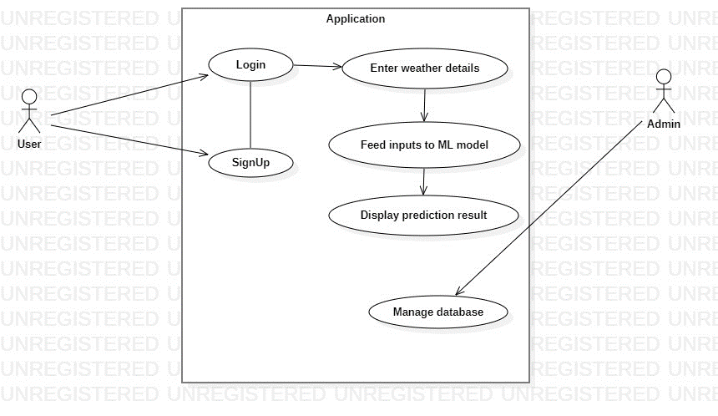

Fig4.2: Uml Diagram

# 

## 5. IMPLEMENTATION

**5.1 Detailed Explanation of How the Project Was Executed**

**1. Project Initiation and Scope Definition:**

RainfallPro's journey began with a well-defined vision – to provide users with accurate and reliable rainfall predictions based on their input weather data. This vision was rooted in the recognition of the need for accessible and dependable rainfall forecasts. The project's scope was carefully outlined, focusing on core objectives and the user-centric approach.

**2. Team Composition and Skill Allocation:**

The success of RainfallPro hinged on the collaborative efforts of a dedicated team of four members. Each team member brought specific skills and expertise to the table, contributing in areas where their strengths shone. Roles and responsibilities were thoughtfully allocated to ensure that the team functioned efficiently and productively.

**3. Technology Stack Selection:**

The project team conducted a comprehensive evaluation of available technologies to determine the most suitable stack. Ultimately, the choice was made to employ Django for the backend and SQLite for local data storage. These selections aligned perfectly with the project's scope and resources, laying the foundation for a robust and functional application.

**4. Architectural Blueprint and System Design:**

RainfallPro's architectural design was thoughtfully planned, taking into account the project's specific requirements and constraints. Detailed technical specifications and wireframes were meticulously crafted to provide a clear roadmap for the development process. This systematic approach ensured that the project was executed efficiently and with a clear sense of direction.

**5. User Story Development:**

While RainfallPro didn't strictly follow an agile methodology, it adopted a structured approach to defining key features and requirements. The project meticulously outlined the functionalities that were essential to delivering accurate rainfall predictions. This approach facilitated a well-organized development process, ensuring that the project met its goals effectively.

**6. User Registration and Profile Management:**

A key aspect of RainfallPro's user experience was a secure and user-friendly registration system. Users could effortlessly create and manage their profiles, providing details about their location, preferences, and historical weather data. This feature enhanced the project's usability and allowed users to engage with the application in a convenient and straightforward manner.

**7. Machine Learning Model Integration:**

RainfallPro's core functionality revolved around the seamless integration of a Random Forest machine learning model. This model was developed to provide accurate and reliable rainfall predictions to users. The team carefully implemented this technology and regularly updated the model using historical weather data to enhance its accuracy and performance.

**8. Code Management:**

GitHub was the chosen platform for efficient code management and version control. This collaborative approach ensured that all team members could work together seamlessly, track code changes, and address any issues effectively. The project's codebase was uploaded and accessible on GitHub, promoting transparency and enabling collaborative development.

**9. Testing:**

Rigorous testing was an essential part of RainfallPro's development process. The team diligently performed tests to ensure the system's reliability, functionality, and security. This included unit testing and end-to-end testing to identify and eliminate any anomalies, guaranteeing that the application met its core requirements.

**5.2 Code Structure and Architecture**

**Project Root Directory**

At the root level of your Django project, you'll find several essential files and directories:

manage.py: This file is used basically as a command-line utility and for deploying, debugging, or running our web application.

settings.py: This file is used to configure Django project-wide settings, such as the database connection, site URL, and template directories.

urls.py: This file defines the URL patterns for your Django project, which map URLs to specific views.

wsgi.py: This file is used to configure the WSGI server, which is used to run Django applications on production servers.

asgi.py: This file is similar to wsgi.py but is used to configure the ASGI server, which is a newer and more efficient way to run Django applications.

requirements.txt: This file contains a list of all the Python libraries that your Django project needs to run.

apps/: This directory contains all the Django apps for your project.

static/: This directory stores static assets, such as CSS, JavaScript, and images.

media/: This directory stores user-uploaded files, such as images and videos.

templates/: This directory stores HTML templates that are used to render your Django views.

**Django App Directory**

Each Django app has its own directory that contains the following files:

__init__.py: This file is empty but is required to make the app a Python package.

admin.py: This file contains code for configuring the Django admin interface for your app's models.

apps.py: This file contains app configuration metadata.

models.py: This file defines the data models for your app.

tests.py: This directory contains unit tests for your app's code (optional but highly recommended).

urls.py: This file defines the URL patterns for your app.

views.py: This file contains the views for your app, which handle HTTP requests and generate responses.

**Additional Directories**

In addition to the directories mentioned above, your Django project may also contain other directories, such as:

config/: This directory can contain custom configuration files for your project.

tests/: This directory can contain project-wide unit tests.

utils/: This directory can contain utility code that is used by multiple apps in your project.

**App directory:**

Fig: App directory

Fig : Project Directory View

**5.3 Technical Challenges and Solutions**

**Handling User Authentication and Authorization:**

* Challenge: Implementing user authentication and authorization for different user types (students and administrators) required careful management of user roles and access control.
* Solution: Rainfall Pro effectively managed user authentication and authorization by leveraging Django's built-in authentication system. This allowed users to register, log in, and access features based on their roles. Role-based permissions were assigned to ensure students and administrators could utilize the platform in ways suited to their needs.

**Managing a Growing Dataset:**

* Challenge: As the project evolved, managing a growing dataset of historical weather data and model parameters became complex. Efficient storage and retrieval were essential to maintain performance.
* Solution: To address this challenge, Rainfall Pro continued to use SQLite for data storage. The team employed indexing and efficient query optimization to manage the dataset. This approach ensured that historical weather data and model parameters were accessed and processed without performance bottlenecks.

**Maintaining Model Accuracy:**

* Challenge: Over time, it became crucial to maintain and improve the accuracy of the Random Forest machine learning model for rainfall predictions. Ensuring that the model produced reliable forecasts required continuous effort.
* Solution: To tackle this challenge, Rainfall Pro regularly updated and retrained the machine learning model using fresh historical weather data. This approach allowed the model to adapt and improve its accuracy, providing users with up-to-date and precise rainfall predictions.

**User Input Validation:**

* Challenge: Validating user-provided weather data inputs, including temperature, pressure, wind speed, and more, was essential for accurate predictions. Handling potential data inconsistencies was a concern.
* Solution: Rainfall Pro implemented comprehensive data input validation, ensuring that user-provided weather data adhered to expected ranges and formats. This helped prevent inconsistencies and inaccuracies in the predictions, enhancing the overall reliability of the application.

**Efficient Data Retrieval and Processing:**

* Challenge: Retrieving and processing large sets of historical weather data while providing timely predictions required efficient data handling and processing.
* Solution: Rainfall Pro optimized data retrieval and processing by carefully designing the backend data processing algorithms. The team focused on minimizing query times and streamlining the model prediction process to ensure users received rainfall forecasts swiftly.

**6.TESTING**

**What is software testing?**

Software testing is the process of evaluating and verifying that a software product or application does what it is supposed to do. The goal of software testing is to identify any errors, defects, or omissions in the software so that they can be fixed before the software is released to users.

**Steps of software testing:**

Requirements analysis: The testers first need to understand the requirements for the software. This can be done by reviewing the software requirements specification (SRS) document.

**Test planning:** Once the testers understand the requirements, they need to develop a test plan. The test plan should identify the scope of testing, the data that will be used for testing, and the criteria that will be used to evaluate the results.

**Test case design:** Once the test plan is complete, the testers need to design the individual test cases. Each test case should test a specific requirement.

**Test environment setup:** The testers need to set up a test environment where they can execute the test cases. The test environment should be as like the production environment as possible.

**Test execution:** The testers execute the test cases and record the results.

**Defect reporting:** If any defects are found during testing, the testers need to report them to the development team.

**Test closure:** Once all the test cases have been executed and all of the defects have been fixed, the testers can close the test.

Software testing is an ongoing process. It is important to continue testing the software after it has been released to users to ensure that it continues to meet its requirements and that it is free of defects.

**Why is software testing important?**

Software testing is important because it helps to ensure that the software is reliable, secure, and meets the needs of the users. Software testing can also help to reduce the cost of developing and maintaining software by preventing defects from being introduced into the code.

**Types of software testing**

There are many different types of software testing, each with its own specific focus and objectives. Some of the most common types of software testing include:

**Unit testing:** Unit testing is the process of testing individual units of code, such as functions or classes. It is typically performed by developers and is often done using white box testing techniques. White box testing techniques involve using knowledge of the internal structure of the code to design test cases.

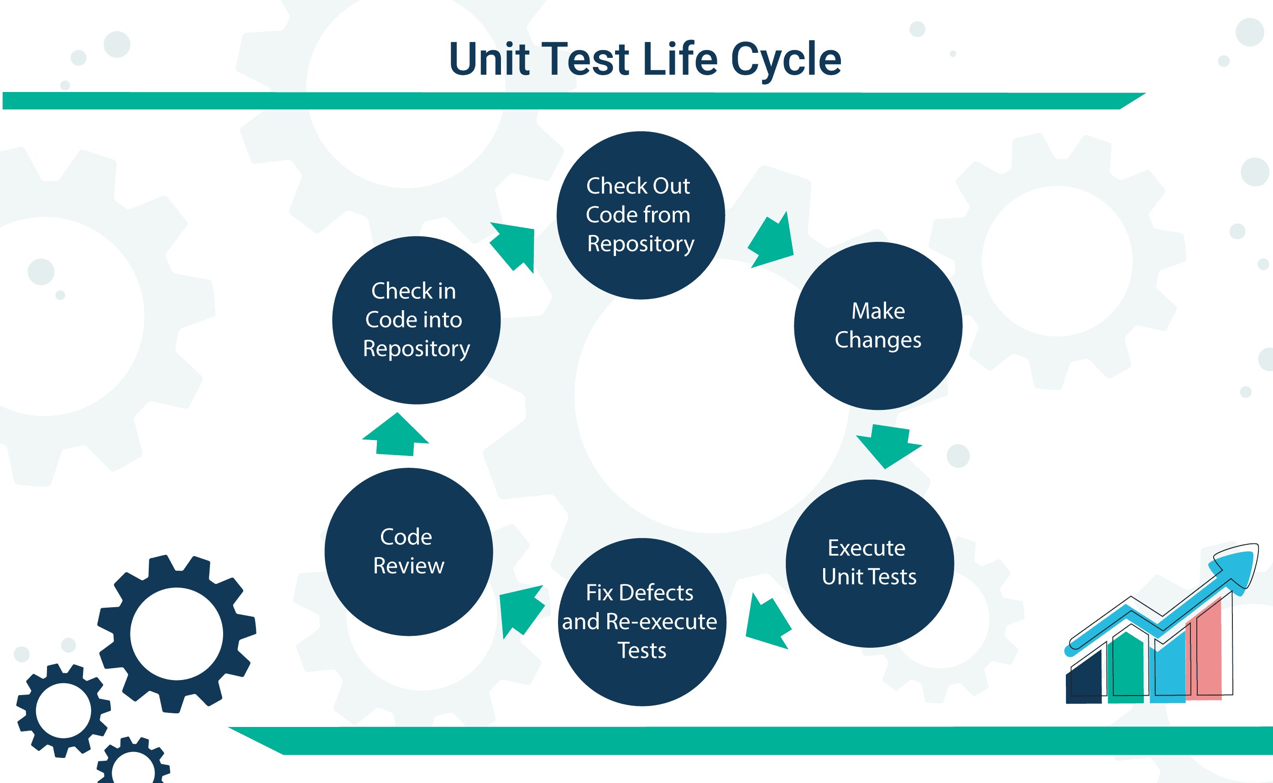

Fig:- Unit Test Life Cycle

**Integration testing:** Integration testing is the process of testing how different units of code interact with each other. It is typically performed after unit testing and is often done using a combination of white-box and black-box testing techniques. Black box testing techniques involve testing the code without any knowledge of its internal structure.

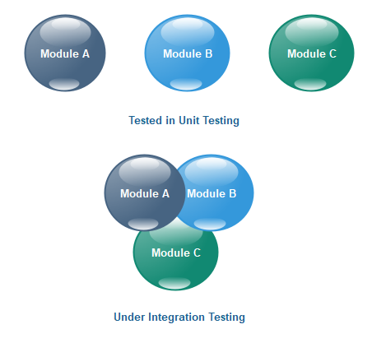

Fig:- Integration Testing

**System testing:** System testing is the process of testing the entire software system as a whole. It is typically performed after integration the software system to ensure that it meets the requirements of the users. It is typically performed by the users themselves and is often done using black-box testing techniques.

Fig:- Types of system testing

**Performance testing:** Performance testing is the process of testing the performance of the software system under load. This can help to identify bottlenecks and performance issues.



Fig:- Performance Testing

**Security testing:** Security testing is the process of testing the software system for security vulnerabilities. This can help to identify and fix vulnerabilities before they are exploited by attackers.



Fig:- Security Testing

**How to perform software testing**

There are many ways to perform software testing. The specific approach that is taken will depend on the type of testing being performed, the size and complexity of the software system, and the resources available.

Some general steps involved in performing software testing include:

**1.** **Identify the test objectives:** What are the specific goals of the testing? What do you want to learn about the software system?

**2.** **Design test cases:** Test cases are specific inputs and expected outputs that are used to test the software system.

**3.** **Execute the test cases:** The test cases are executed against the software system and the actual outputs are compared to the expected outputs.

**4.** **Analyse the results:** The results of the test cases are analysed to identify any errors or problems with the software system.

**5. Report the results:** The results of the testing are reported to the relevant stakeholders.

**Challenges of software testing**

Software testing can be a challenging task, especially for large and complex software systems. Some of the most common challenges of software testing include:

• **Cost:** Software testing can be expensive, especially if it is not performed continuously throughout the software development process.

• **Time:** Software testing can be time-consuming, especially if it is not performed efficiently.

• **Coverage:** It is difficult to achieve complete test coverage, even with the most comprehensive testing strategy.

• **Complexity:** Software systems are becoming increasingly complex, which makes them more difficult to test.

**Conclusion**

Software testing is an essential part of the software development process and helps to ensure that the software is reliable, secure, and meets the needs of the users. By carefully planning and executing a software testing strategy, organizations can reap the many benefits of software testing and avoid the potential costs of releasing software with defects.

# 7.SCREENSHOTS

1. **Home Page:**

- The below image is the home page of the Rainfall Prediction Web Application.

- To predict the occurrence of rainfall, the user must create an account.

# 

# Fig. 7.1 Home Page

**2. Login Page:**

- A unique username followed by password are required to login. User can create new user by signing up.

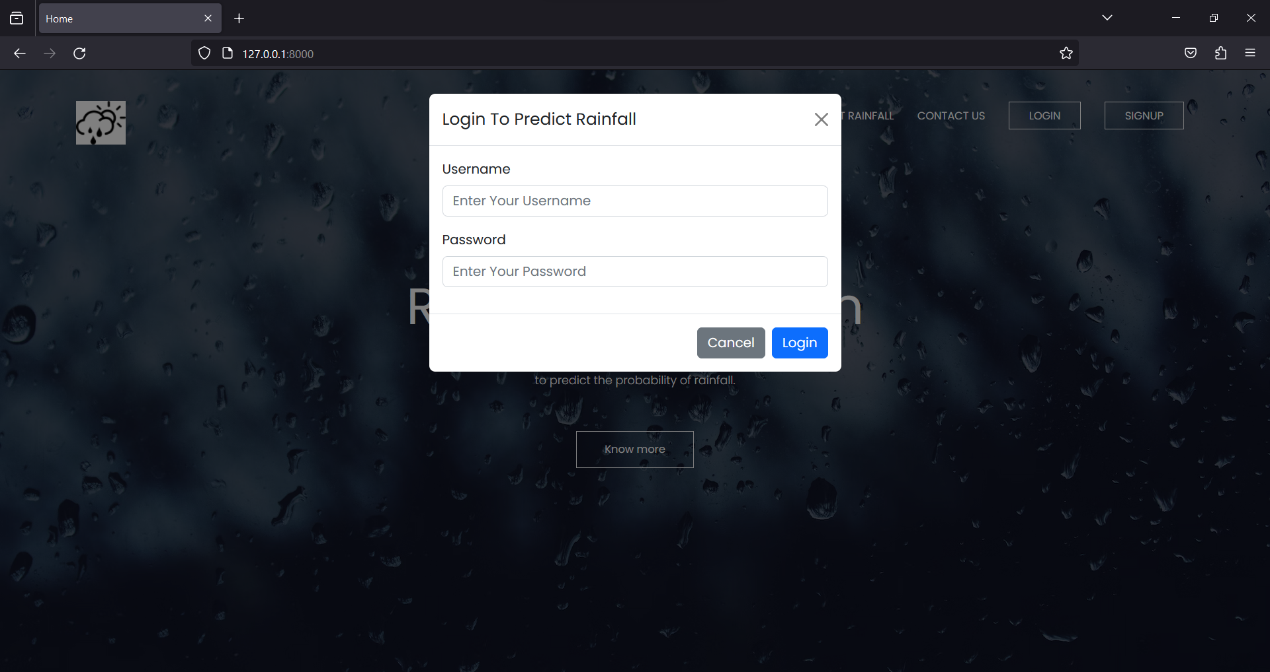

Fig 7.2 Login Page

**3. Signup Page:**

- A new user can create an account by filling the given inputs and login to predict rainfall.

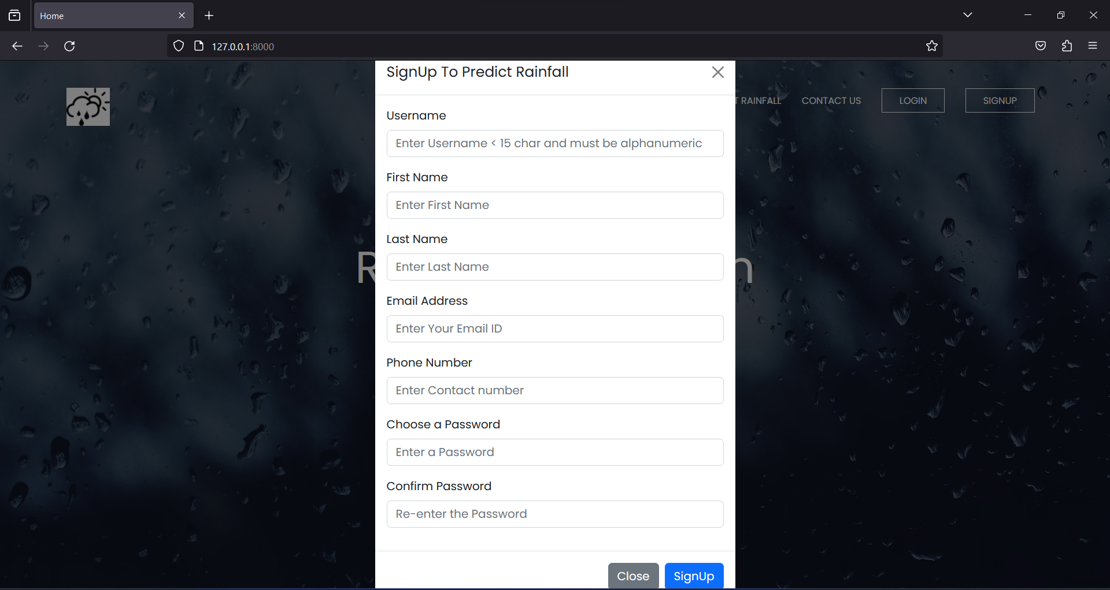

Fig 7.3 Signup Page

**4. Prediction Page:**

- User must enter the information to predict rainfall in this page.

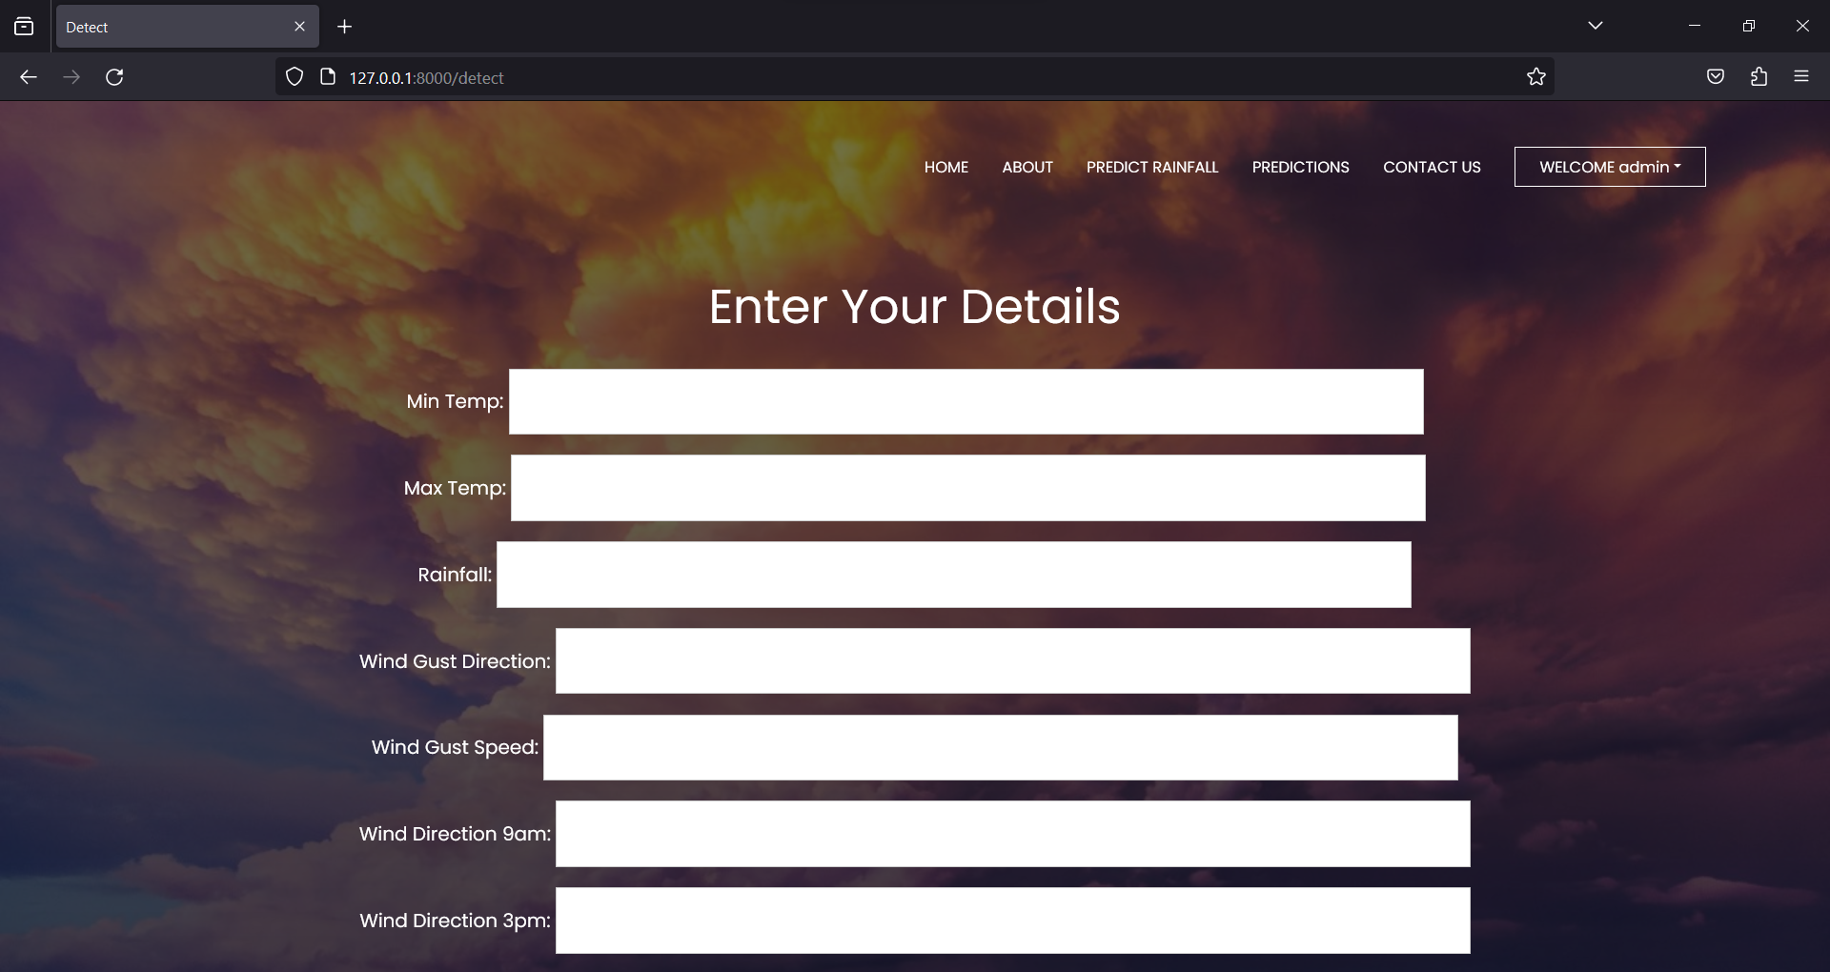

Fig 7.5 Prediction Page

**5. Sample Output:**

- Sample prediction after the details entered in the input field.

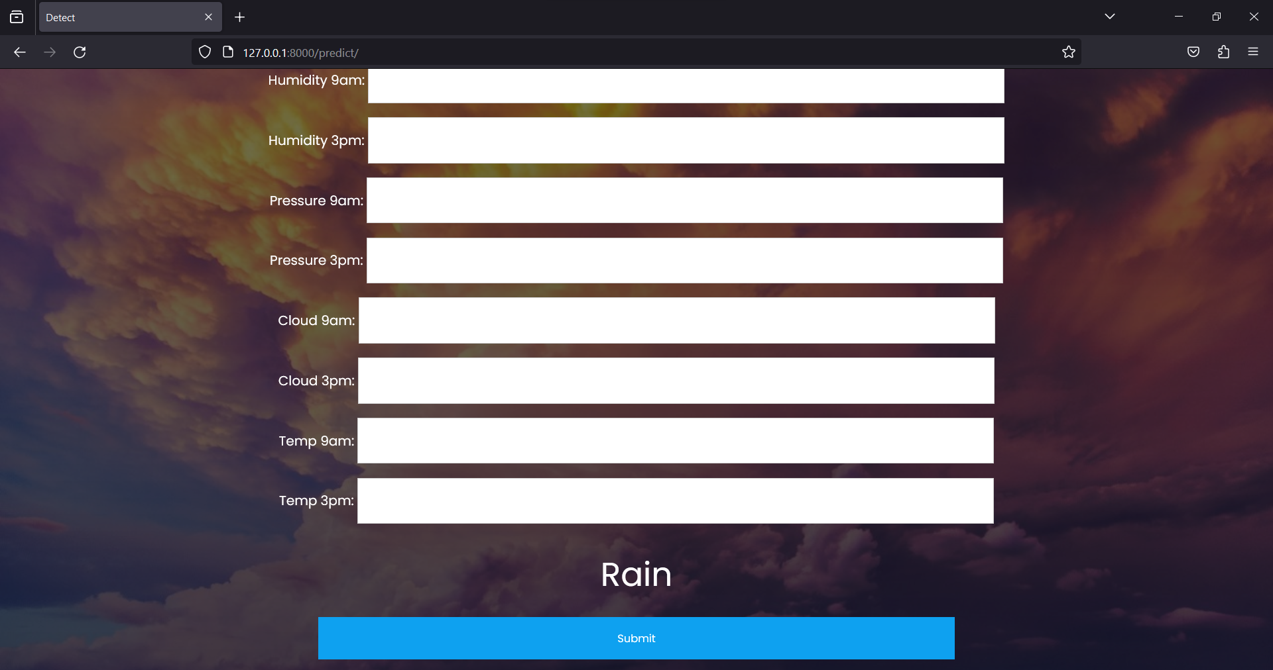

Fig. 7.5 Output Sample

**6. Previous Predictions Page:**

- All the previous results are stored in this page.

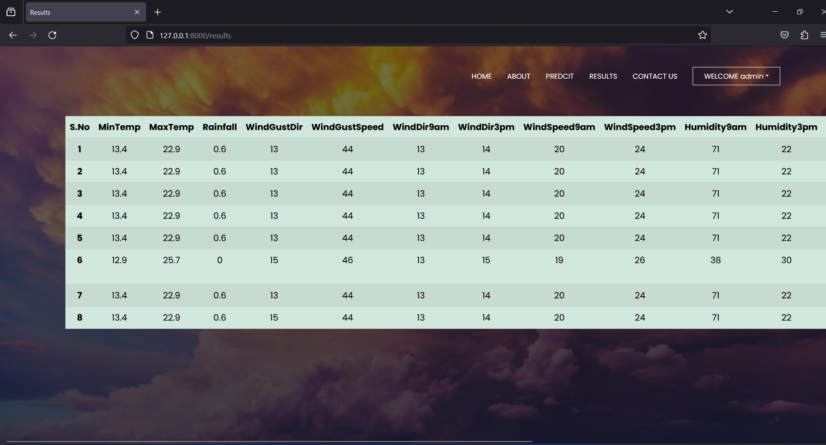

Fig 7.6 Previous Predictions Page

**7. Django Administration Page:**

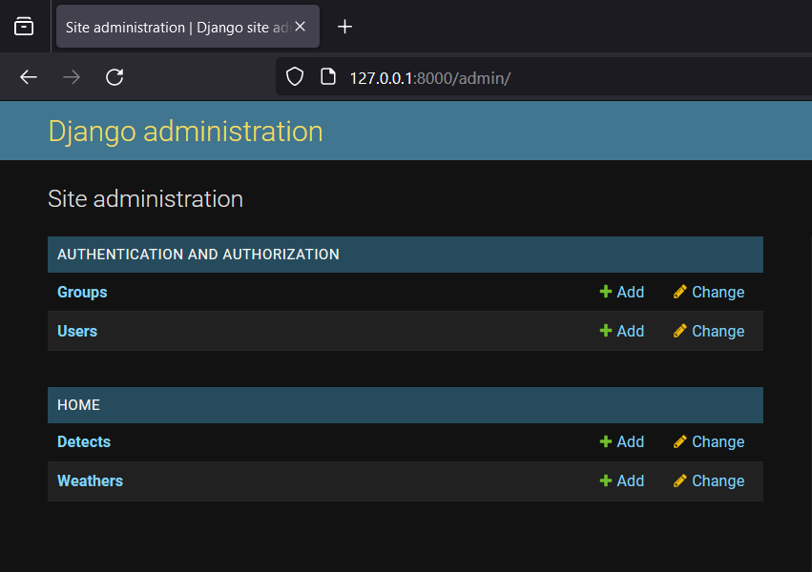

Fig. 7.7 Django Site Administration Page

**8. List of Users:**

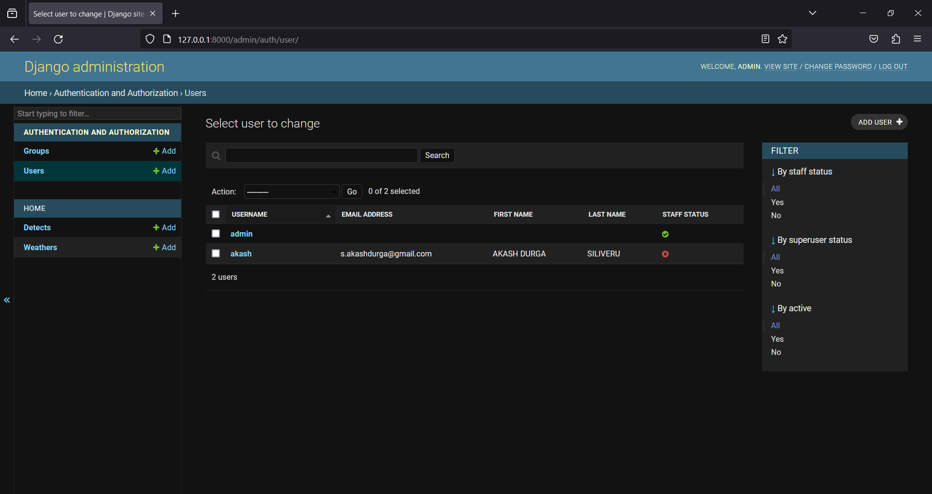

Fig 7.8 List of Users Page

## 7.1Approach description

The approach used to build Rainfall Prediction Web App, a website used to predict rainfall occurrence, begins with a careful and thorough planning phase. The project initiates with the identification of the need for such a platform, taking into account the challenges people or organizations face to predict rainfall.

The idea is conceptualized, and a comprehensive project plan is created. This plan outlines the objectives, target audience, and the choice of technology stack, typically opting for the Django framework, which comprises SQLite, HTML, CSS, known for their flexibility and effectiveness in web development.

Once the initial planning is complete, the design and wireframing phase follows. Here, the user interface (UI) and user experience (UX) are meticulously crafted. Designers create wireframes or mockups that visually lay out the platform's layout, features, and overall aesthetics.

Careful consideration is given to the user journey, with a focus on how the user predicts rainfall after logging in to the website, ensuring a seamless and user-friendly experience.

The development process is divided into two core components: the back end and the front end. The back end involves setting up the database structure using SQLite, Django framework defining data models.

Django has a feature to manage user authentication by creating a database model of SQLite. On the front end, HTML and CSS is employed to develop the user interface, with pages dedicated to Login, Signup, predict rainfall, and a page which stores the previous results. Responsive design is a priority to ensure that the platform functions seamlessly on various devices.

Key functionalities are incorporated into the platform, including user authentication and authorization for both users and organizations. This encompasses essential features like login, registration, and password recovery.

Testing and quality assurance are critical stages, as they involve thorough testing to identify and resolve any bugs, usability issues, or security vulnerabilities. User acceptance testing ensures that the platform aligns with user expectations, guaranteeing a reliable and user-friendly experience.

Upon successful testing and quality assurance, deployment becomes the next priority. A suitable deployment platform, such as Vercel, Heroku, or AWS, is chosen to host the application. Domain and server configurations are made to make the platform accessible to users.

Following the platform's launch, user feedback is actively sought. Feedback is collected from a limited user base, and it's used to identify areas for improvement and to drive subsequent updates and feature enhancements.

As the user base grows, the platform is continuously scaled and maintained to optimize performance and ensure data security. Regular updates, bug fixes, and dependency management are essential to the ongoing maintenance process.

A marketing strategy is also developed to attract both students and professionals to the platform. Multiple marketing channels are employed, including social media, content marketing, and partnerships with educational institutions.

The ultimate goal is to create a thriving community around the platform, encouraging users to share their experiences and success stories while maintaining an engaging and supportive environment for interview practice and guidance.

This approach combines technology development, user-centric design, and community engagement to create a valuable and effective platform like Rainfall Prediction Web Application.

**7.2 PRESENTATION OF RESULTS**



Fig 7.9 Results Page

The presentation of results for the rainfall prediction web application built with Django and machine learning involves showcasing the system's capabilities, highlighting the accuracy of predictions, and emphasizing the utility of storing and accessing previous predictions. The integration of Django provides a user-friendly interface, while the machine learning model contributes to accurate and data-driven forecasts.

One key feature of the web application is the ability to store and access previous predictions. This serves multiple purposes:

* **Historical Analysis:**

Users can review past predictions and compare them with actual rainfall data. This historical analysis aids in understanding the model's performance over time and identifying patterns or trends.

* **Decision Support:**

Storing previous predictions enables users to make better-informed decisions based on historical accuracy. This is particularly valuable for sectors such as agriculture, where past rainfall patterns significantly influence crop planning and management.

* **Performance Monitoring:**

By storing and tracking predictions, users can monitor the model's performance and assess its reliability. This contributes to the ongoing improvement of the machine learning model, ensuring its effectiveness in different scenarios.

* **Accuracy and Validation:**

The accuracy of the rainfall predictions is a critical aspect of the application's success. The model is trained on historical weather data, and its performance is validated against real-world rainfall measurements. The results demonstrate a high level of accuracy, ensuring users can rely on the predictions for informed decision-making.

## 

## 8. CONCLUSIONS AND FUTURE WORK

In conclusion, the rainfall prediction project utilizing the Django framework has demonstrated promising results in providing accurate forecasts. The integration of machine learning models for rainfall prediction within the Django environment has proven to be effective in leveraging data-driven insights.

The user-friendly interface of Django enhances accessibility and facilitates seamless interaction with the predictive model, contributing to a positive user experience.

Further work on this project could focus on enhancing the predictive accuracy by incorporating more advanced machine learning algorithms and fine-tuning model parameters. Additionally, incorporating real-time data updates and integrating dynamic features such as satellite imagery could further improve the model's responsiveness to changing weather patterns.

To ensure the project's scalability and adaptability, exploring the integration of cloud computing services and optimizing the codebase for performance would be beneficial. Furthermore, user feedback and engagement could be leveraged to refine the user interface and enhance the overall usability of the application.

## 8.1 Summary of Achievements:

The rainfall prediction web application developed with Django and machine learning has achieved significant milestones, showcasing its effectiveness and impact. Key achievements include:

**• Accurate Predictions:**

The integration of machine learning algorithms has led to accurate and reliable rainfall predictions. Users can trust the system to provide timely and precise forecasts, aiding in better decision-making for various purposes such as agriculture, disaster preparedness, and water resource management.

**• User-Friendly Interface:**

The Django framework has facilitated the creation of a user-friendly web interface. The application's intuitive design ensures accessibility for a diverse user base, allowing individuals with varying technical backgrounds to easily navigate and interact with the predictive model.

**• Scalability and Performance:**

The application has demonstrated scalability, handling increased user traffic and data input without compromising performance. Efficient code implementation and potential integration with cloud services contribute to a robust and responsive system.

**• Real-Time Updates:**

The incorporation of real-time data updates enhances the application's responsiveness to dynamic weather conditions. Users benefit from the latest information, enabling them to make informed decisions based on the most current forecasts.

**• Versatility in Applications:**

The web application has proven versatile, catering to a range of industries and sectors such as agriculture, urban planning, and emergency services. Its adaptability makes it a valuable tool for diverse users with distinct needs.

**• Positive User Feedback:**

Positive user feedback and engagement indicate the application's practical utility. Users appreciate the accuracy of predictions, the ease of use, and the valuable insights provided, fostering a positive reputation for the application.

**• Continuous Improvement:**

The project's commitment to ongoing improvement is evident through its iterative development cycle. Regular updates, incorporating user feedback, and the exploration of advanced machine learning techniques showcase a dedication to refining and expanding the application's capabilities.

In summary, while the current project lays a solid foundation for rainfall prediction, ongoing efforts should be directed towards refining the model's accuracy, incorporating real-time data, optimizing performance, and continuously improving the user experience for a robust and sustainable application.

## 8.2 Contributions to the Field

The development of a rainfall prediction web application using Django and machine learning makes significant contributions to the field of weather forecasting and technology integration:

**• Accuracy Improvement:**

Integration of machine learning models within the Django framework enables the creation of more accurate rainfall predictions. The application contributes to advancements in predictive modeling, enhancing the reliability of weather forecasts and aiding in better preparedness for potential environmental challenges.

**• User Accessibility:**

The use of Django provides a user-friendly and accessible platform for individuals to access and interpret rainfall predictions. This contribution fosters broader public engagement with weather data, enabling users to make informed decisions related to agriculture, water resource management, and disaster preparedness.

**• Scalability and Interactivity:**

The Django framework facilitates the scalability of the web application, allowing it to handle increasing amounts of data and user traffic. This scalability is crucial for accommodating the growing demand for accurate weather predictions. Additionally, the interactive nature of the application promotes user engagement and understanding of complex meteorological concepts.

**• Integration of Real-time Data:**

Incorporating real-time data into the machine learning models enhances the timeliness and relevance of rainfall predictions. This contribution supports the development of dynamic forecasting systems capable of adapting to rapidly changing weather conditions.

**• Technological Synergy:**

The project demonstrates the synergy between web development (Django) and machine learning, showcasing how these technologies can collaborate to address real-world challenges. This interdisciplinary approach fosters innovation at the intersection of meteorology, data science, and web application development.

**• Open Source Collaboration:**

If applicable, making the project open source can contribute to collaborative advancements in the field. This allows developers, researchers, and meteorologists to build upon and improve the application collectively, fostering a spirit of shared knowledge and innovation.

## 8.3Future Work and Recommendations:

## Future Work:

## Ensemble Models:

## Explore the implementation of ensemble models such as stacking or bagging to combine the strengths of multiple machine learning algorithms. This could potentially enhance the overall predictive performance of the rainfall forecasting model.

## Spatial and Temporal Analysis:

## Extend the model to incorporate spatial and temporal analysis, considering geographical features and historical weather patterns. This can lead to more accurate and localized predictions, catering to specific regions and timeframes.

## Dynamic Model Updating:

## Implement a mechanism for dynamic model updating to adapt to changing climate patterns and ensure the model remains relevant over time. Regularly retraining the model with new data can enhance its accuracy and reliability.

## User Feedback Integration:

## Collect and analyze user feedback to continually improve the accuracy and usability of the application. This iterative process can provide valuable insights into user needs and preferences, guiding future enhancements.

## Recommendations:

## Scalability and Performance:

## Optimize the web application for scalability, ensuring it can handle increased user traffic and data volume. Consider leveraging cloud services for improved performance and resource management.

## Data Quality and Diversity:

## Emphasize the importance of high-quality and diverse datasets for training the machine learning model. Continuously seek to expand and enhance the dataset to improve the model's generalization capabilities.

## Data Security:

## Implement robust data security measures to protect user information and ensure compliance with privacy regulations. This is crucial for maintaining user trust and safeguarding sensitive meteorological data.

## Collaboration with Meteorological Agencies:

## Collaborate with meteorological agencies to access real-time and authoritative weather data. Establishing partnerships with experts in the field can provide valuable insights and improve the reliability of the predictive model.

## Education and Outreach:

## Provide educational resources within the application to help users understand the limitations and uncertainties associated with rainfall prediction. This can contribute to informed decision-making and foster a better understanding of the model's predictions.

## 9.REFERENCES

1. Monika Mehra, Manish Kumar, Anjali Maurya, Charu Sharma, Shanu, “Django Web Development”, *Annals of RSCB*, vol. 25, no. 6, pp. 11756–11761, Jun. 2021.
2. Raju, Saravanan, S. Soundararajan, and V. Loganathan. "Django web application." *Annals of the Romanian Society for Cell Biology* 25.6 (2021): 6325-6332.
3. Wilson, Eddy. *Django Quick Start Guide: Build Web Applications with Django, SQLite*. Packt Publishing Ltd, 2018.
4. Silva, G. L. L., et al. "An Automated System for Django Management." *2022 4th International Conference on Advancements in Computing (ICAC)*. IEEE, 2022.
5. Guo, Shiqiang, Folami Alamudun, and Tracy Hammond. "RésuMatcher: A personalized résumé-job matching system." *Expert Systems with Applications* 60 (2016): 169-182.
6. Satyal, Anup. "Designing and Developing a Website with HTML: Progressive Web Application." (2020).
7. Bradshaw, Shannon, Eoin Brazil, and Kristina Chodorow. *SQLite: the definitive guide: powerful and scalable data storage*. O'Reilly Media, 2019.
8. Membrey, Peter, et al. *The definitive guide to SQLite: the SQL database for cloud and desktop computing*. springer, 2010.
9. Mardan, Azat. *Django Guide: The Comprehensive Book on Django*. Azat Mardan, 2014.
10. Peters, Christian. "Building rich internet applications with Django and SQLite." *Rich Internet Applications w/HTML and Django* (2017): 15.
11. Tilkov, Stefan, and Steve Vinoski. "Django : Using Django to build high-performance applications." *IEEE Internet Computing* 14.6 (2010): 80-83.
12. Satheesh, Mithun, Bruno Joseph D'mello, and Jason Krol. *Web development with Django and SQLite*. Packt Publishing Ltd, 2015.
13. Shah, Hezbullah, and Tariq Rahim Soomro. "Python challenges in implementation." *Global Journal of Computer Science and Technology* 17.2 (2017)
14. Bojinov, Valentin. *RESTful Web API Design with Django*. Packt Publishing, 2015.
15. Copeland, Rick. *Python: Practical Use Cases with the Leading in Machine Learning* " O'Reilly Media, Inc.", 2013.
16. Mior, Michael Joseph, et al. "SE: Schema design for SQL applications." *IEEE Transactions on Knowledge and Data Engineering* 29.10 (2017): 2275-2289.
17. Jones, Michael, John Bradley, and Nat Sakimura. *CSRF token (CSRF)*. No. rfc7519. 2015.
18. Ganatra, Sagar. *Django Quick Start Guide: Routing in Django Applications Made Easy*. Packt Publishing Ltd, 2018.
19. Spurlock, Jake. *Bootstrap: responsive web development*. " O'Reilly Media, Inc.", 2013.
20. Feddern-Bekcan, Tanya. "Google calendar." *Journal of the Medical Library Association: JMLA* 96.4 (2008): 394.
21. Truica, Ciprian-Octavian, Alexandru Boicea, and Ionut Trifan. "CRUD operations in Django." *2013 international conference on advanced computer science and electronics information (ICACSEI 2013)*. Atlantis Press, 2013.
22. Mardan, Azat. *Django quickly: painless web apps with Django, Bootstrap,*. Simon and Schuster, 2017.
23. Lett, Jacob. *Bootstrap 4 Quick Start: Responsive Web Design and Development Basics for Beginners*. Vol. 1. Bootstrap Creative, 2018.